 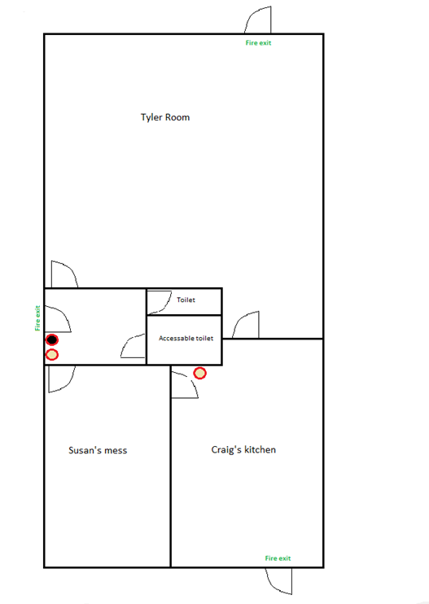

**Tyler room**

**Accessible toilet**

**Toiletilet**

**Susan’s Mess**

**Craig’s Kitchen**

**Fire exit**

**Fire exit**

**Fire exit**

CO2 extinguisher

Foam extinguisher