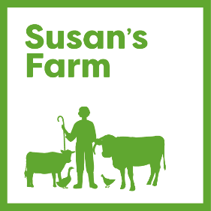

TRUSTEE APPLICATION FORM

Personal Details

Name:

Address and postcode:

Telephone Number/Mobile:

Email Address:

Do you have a current DBS check in place?

If yes, what date?

Is this registered with the DBS Checking Service? Yes/No

Which of the following skills or experience could you bring to the board? Please tick all that apply.

Human Resources |  | Business Management
Financial/accounting |  | Marketing/PR
Fundraising |  | Community relations
Legal |  | Project Management
Strategic planning |  | Safeguarding/Welfare
Quality Assurance |  | Risk Management
Information Technology |  | Procurement/Commissioning
Financial management |  | Other (please specify)

Please indicate why you want to become a trustee of Susan’s Farm and how you think your own skills and experience would enable you to fulfil the role of a Trustee as described in the role description (500 words)

Please supply names and addresses of 2 people (not relatives) who are willing to act as referees for you.

Name: Name:

Email: Email:

Address: Address:

Tel No: Tel No:

Trustee applicant’s declaration of eligibility:

I declare that:
• I am over age 18.
• I am not an undischarged bankrupt.
• I have not previously been removed from trusteeship of a charity by a Court or the Charity Commission.
• I am not under a disqualification order under the Company Directors' Disqualification Act 1986.
• I have not been convicted of an offence involving deception or dishonesty (unless the conviction is spent).
• I am, in light of the above, not disqualified by the Charities Act 1993 (section 72) from acting as a charity trustee.
• I undertake to fulfil my responsibilities and duties as a trustee of Susan’s Farm in good faith and in accordance with the law and within Susan’s Farm’s objectives/mission and Code of Conduct for trustees.
• I do not have any financial interests in conflict with those of Susan’s Farm (either in person or through family or business connections) except those that I have formally notified in a conflict-of-interest statement. I will specifically notify any such interest at any meeting where trustees are required to make a decision which affects my personal interests, and I will absent myself entirely from any decision on the matter and not vote on it.

Thank you for completing this application form and for your interest in becoming a Trustee of Susan’s Farm.

This form should be marked ‘Confidential’ and returned to the Chair of the Trustees, 145 Houghton Road, Houghton, Carlisle, Cumbria CA3 0LD or emailed to info@susansfarm.co.uk.co.uk.

Please also include your CV.

Please note that all data will be held in the strictest confidence and in compliance with the General Data Protection Regulation and will only be used for the purpose of selection of trustees.

