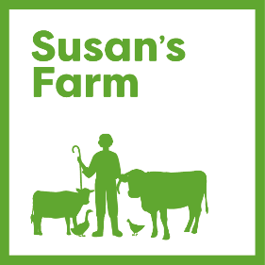

VOLUNTEER APPLICATION FORM

Volunteer Role applied for: ………………………………………………………………..

Personal Details

Name:

Address and postcode:

Telephone Number/Mobile:

Email Address:

Do you have a current DBS check in place?

If yes, what date?

Is this registered with the DBS Checking Service? Yes/No

Relevant Experience/Personal Qualities applicable to this role:

Availability:
Which days were you thinking of volunteering, for how long and how frequently?

Medical Information and Consent (to be completed by Parent/Legal Guardian if under 18)

In case of emergency and as part of the SUSAN’s FARM responsibility to its volunteers, ALL volunteers are required to complete this medical information form as accurately as possible. Details will be held securely with access restricted to authorised officers only.

Next of kin: | Relationship: | Mobile phone:
Doctor’s name: | Surgery: | Doctor’s phone number:
Do you have any allergies, for example medication/food/animals | Yes/No  If Yes, please state details:
Are you taking any regular medication? | Yes/No  If Yes, for what reason:
Do you have any long-term illnesses or injuries? | Yes/No  If Yes, please state details:
Please confirm you are able to supervise yourself and others  Please confirm that you have good social and interaction skills and can deal with potentially difficult/sensitive situations | Yes/No/Not Sure  Yes/No/Not Sure

DECLARATION: I consider myself to be physically and psychologically fit and capable of full participation and agree to notify SUSAN’s FARM of any changes to the medical information provided. Furthermore, in the event of injury I give my permission for the staff appointed by SUSAN’s FARM to obtain emergency medical treatment for me.
Signed: | Date:

References:

Please give names and addresses of 2 people (not relatives) who are willing to act as referees for you.

Name: Name:

Email: Email:

Address: Address:

Tel No: Tel No:

You will not be able to commence volunteering until references are taken up and are satisfactory.

Please return completed form to info@susansfarm.co.uk or post for the attention The Admin Officer, Susan’s Farm, 145 Houghton Road N, Houghton, Cumbria, CA3 0LD

